# CS 255 System Design Document Template

This template lays out all the different sections that you need to complete for Project Two. Each section has guidance to prompt your thinking. You will need to continually reference the interview transcript as you work to make sure that you are addressing your client’s needs. There is no required length for the final document. Instead the goal is to complete each section based on what your client’s needs are. Remove this note when you are finished, and replace all bracketed text with the relevant information.

## UML Diagrams

### UML Use Case Diagram

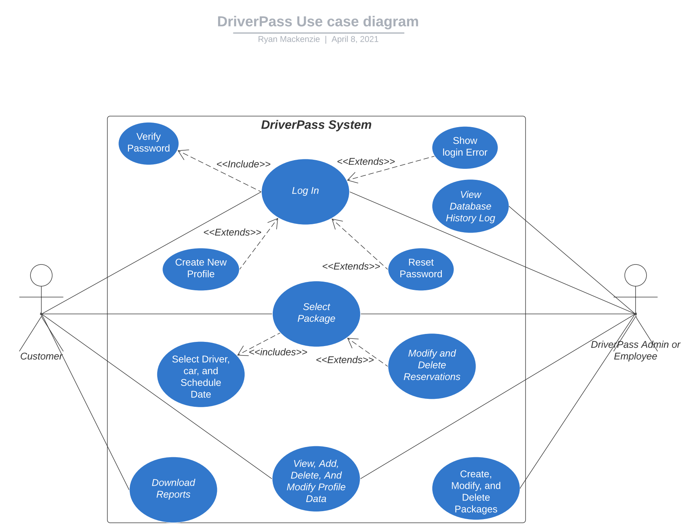

### UML Activity Diagrams

### UML Sequence Diagram

### UML Class Diagram

## Technical Requirements

The system will be based in the cloud. Using either Amazon Web Services or Microsoft Azure, we can purchase both a cloud server and a cloud database. This removes the need for the DriverPass company to purchase and maintain any physical hardware. Cloud services actively scale as more space and performance are needed, which is perfect for Driverpass as it may grow quickly. The cloud database will store all information including user info, appointment reservations, and more. We can handle the authentication from user to the server/database using the REST API which can handle secure data transmissions. The rest of the objects in the software can be coded in JAVA which also works with the REST API. All the code will be stored and ran on the cloud server which will enable 24/7 access to users. This should be everything we need to fully set them up with the system they have requested.